**Basic understanding of Arduino IDE and programming**

* Arduino IDE (Integrated Development Environment) allows us to draw the sketch and upload it to the various Arduino boards using code. The code is written in a simple programming language similar to C and C++.
* The initial step to start with Arduino is the IDE download and installation.
* There are two types of brackets used in the Arduino coding, which are listed below:
  + 1. Parentheses ( )
    2. Curly Brackets { }
* Parentheses ( )

The parentheses brackets are the group of the

arguments, such as method, function, or a code

statement. These are also used to group the math

equations.

* Curly Brackets { }

The statements in the code are enclosed in the curly

brackets. We always require closed curly brackets to

match the open curly bracket in the code or sketch.

* There are two types of line comments, which are listed below:

1. Single line comment
2. Multi-line comment

Coding Screen:

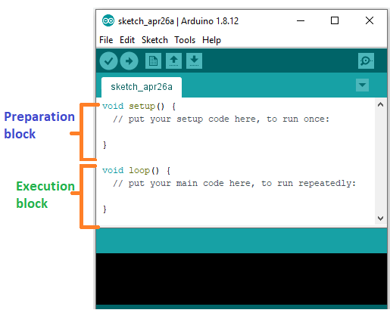

**For example:**

void setup ( )

{

Coding statement 1;

Coding statement 2;

.

.

.

Coding statement n;

}

void loop ( )

{

Coding statement 1;

Coding statement 2;

.

.

.

Coding statement n;

}

Note:

* The void setup () would include pinMode as the main function.

1. The Syntax is: pinMode (pin, mode)
2. pin: It is the pin number. We can select the pin number according to the requirements.
3. Mode: We can set the mode as INPUT or OUTPUT according to the corresponding pin number.

* The void loop () would include **digitalWrite( )** and **delay ( )** as the main function.

1. The syntax is: digitalWrite( pin, value HIGH/LOW).

Pin: We can specify the pin number or declared variable.

1. delay ( )

The delay () function is a blocking function

to pause a program from doing a task

during the specified duration in milliseconds.

For example, - delay (2000).

Example: To light the LED connected to pin number 13. We want to ON the LED for 4 seconds and OFF the LED for 1.5 seconds.

Code:

void setup ()

{

pinMode ( 13, OUTPUT); // to set the OUTPUT mode of pin number 13.

}

void loop ()

{

digitalWrite (13, HIGH);

delay (4000); // 4 seconds = 4 x 1000 milliseconds

digitalWrite (13, LOW);

delay (1500); // 1.5 seconds = 1.5 x 1000 milliseconds

}